# Exercises: Playing with Cryptocurrency Wallets

In this exercise we shall install a **cryptocurrency wallet** and will play with **cryptocurrencies**. We shall install wallet software, generate private keys and digital currency addresses, send transactions, watch the transaction processing.

For this exercise we shall use Web-based crypto-wallet software called **MyEtherWallet** (**MEW**), which behaves like locally installed Ethereum crypto wallets, but is accessible through the Web, without any installation.

* MyEtherWallet is a **client-side wallet software**. It does not store your private keys, neither sends them at the server-side. Keeping your keys is a secure place is your obligation.
* MEW connects to the Ethereum blockchain through **REST API** (using client-side AJAX calls from JavaScript). The MyEtherWallet API is officially documented here: <https://www.myetherapi.com>.
* You can create / export / import **wallet keys**, sign and **send transactions** and **browse the blockchain**.
* MEW works with the **main** (production) Ethereum network, as well as with testing networks (**testnets**) like Ropsten, Kovan and Rinkeby.

## Create a Crypto Wallet

First, we shall generate an Ethereum wallet.

1. Open [https://www.myetherwallet.com](https://www.myetherwallet.com/) in your Web browser. It should look like this:

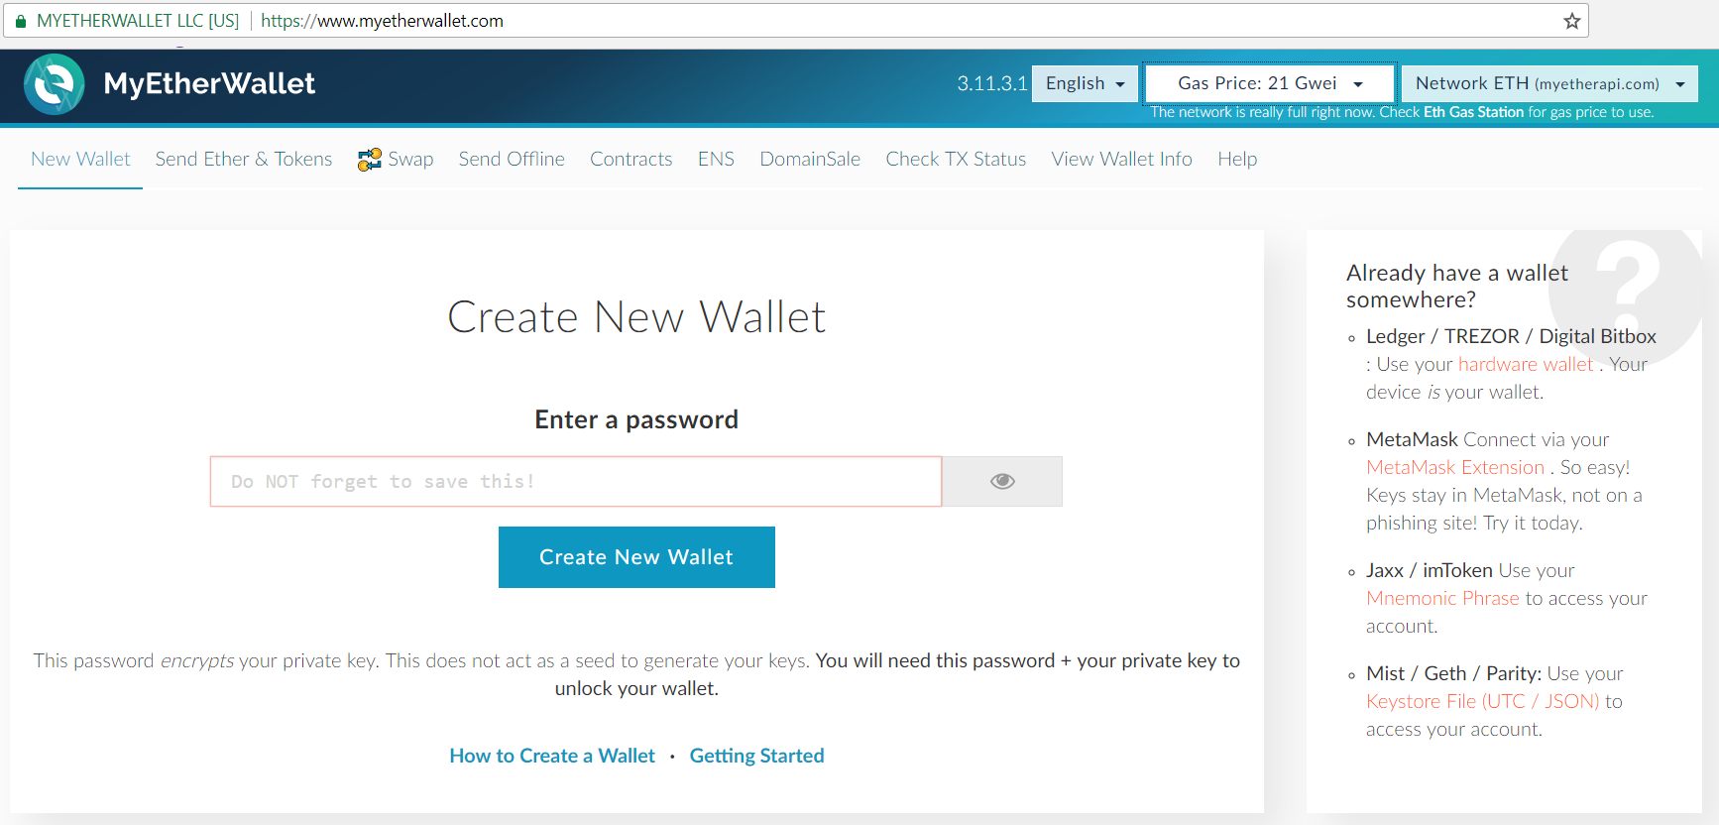

1. Now look at upper right corner and choose to connect to one of the **test networks** there. The default is the main net which uses real ethers. We want to use test net ethers, so choose the **“Ropsten” test net**.

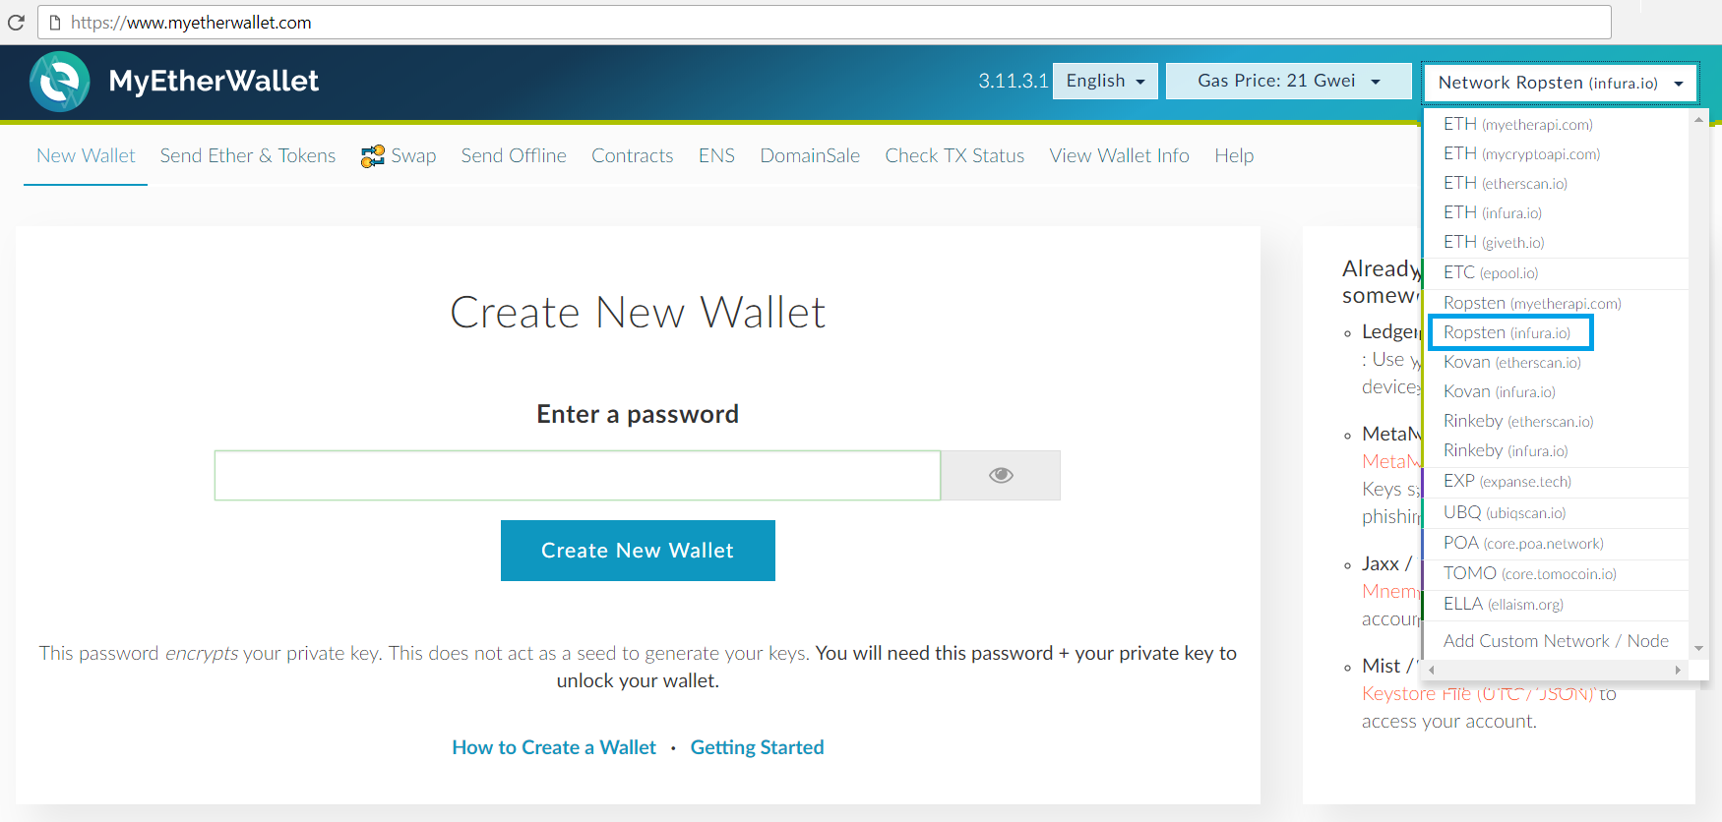

1. **Create a New Wallet**. First you should write password and then create the wallet.

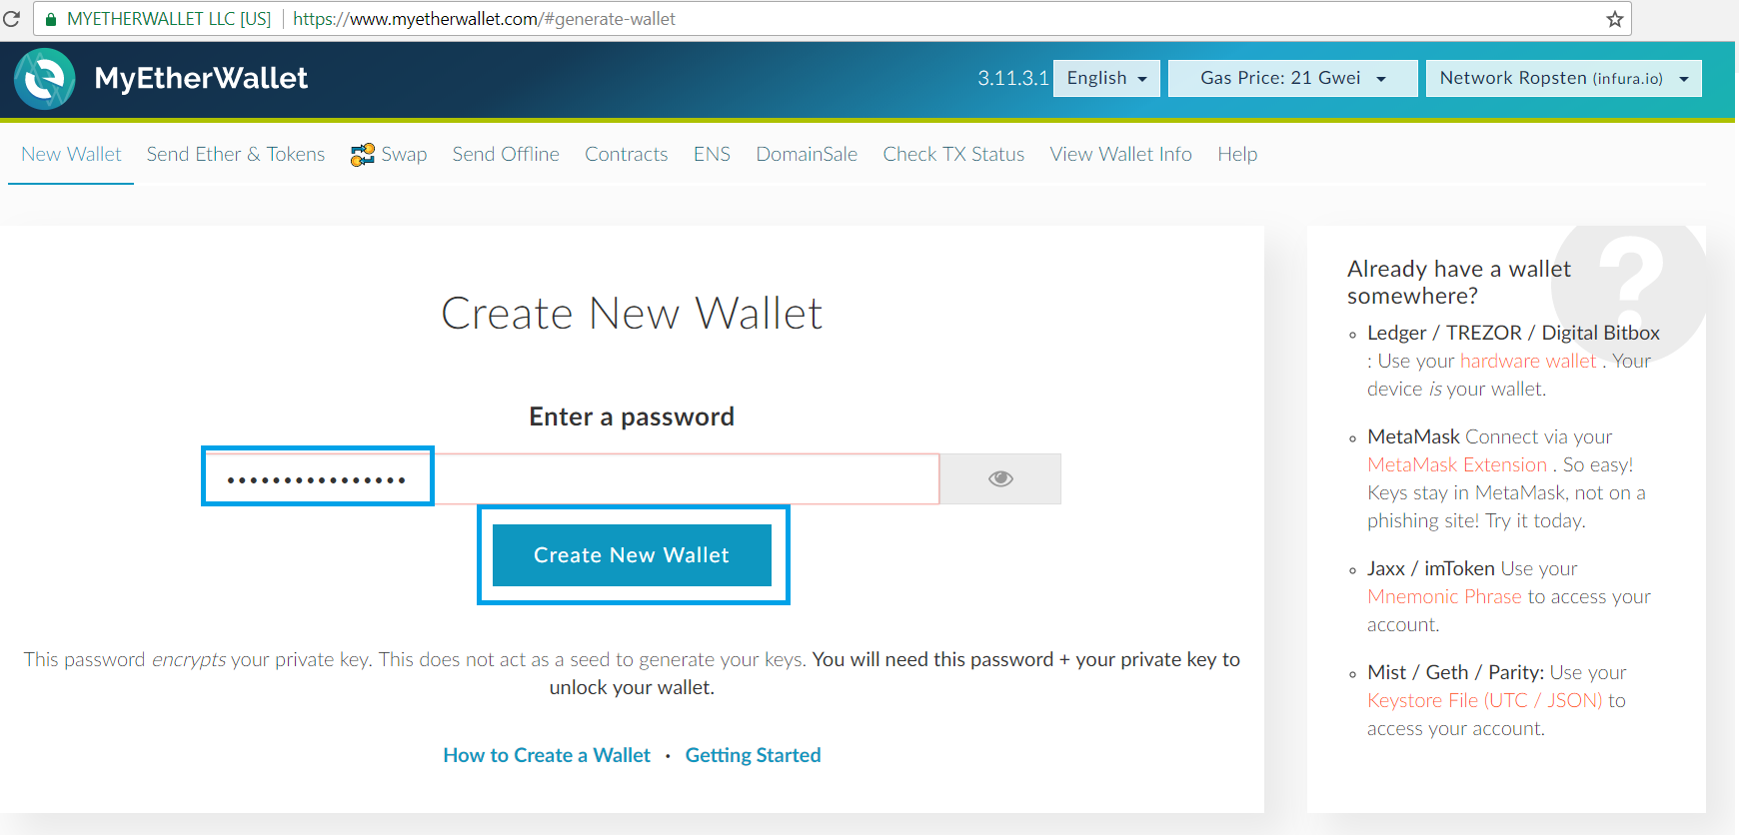

This will generate **a random private key** in your Web browser along with its corresponding Ethereum address. Your private key may be stored in an **encrypted keystore file** (recommended) or can be kept in **pure unencrypted** format (not recommended, unless when you print it on a paper).

1. Download the **encrypted** **JSON keystore file** then continue.

* ** Do not lose it!
* ** It cannot be recovered if you lose it.
* ** Do not share it!
* ** Your funds will be stolen if you use this file on a malicious / phishing site.
* ** Make a backup in a secure place, e.g. on a paper or several USB drives!
* ** Secure it like the millions of dollars it may one day be worth.

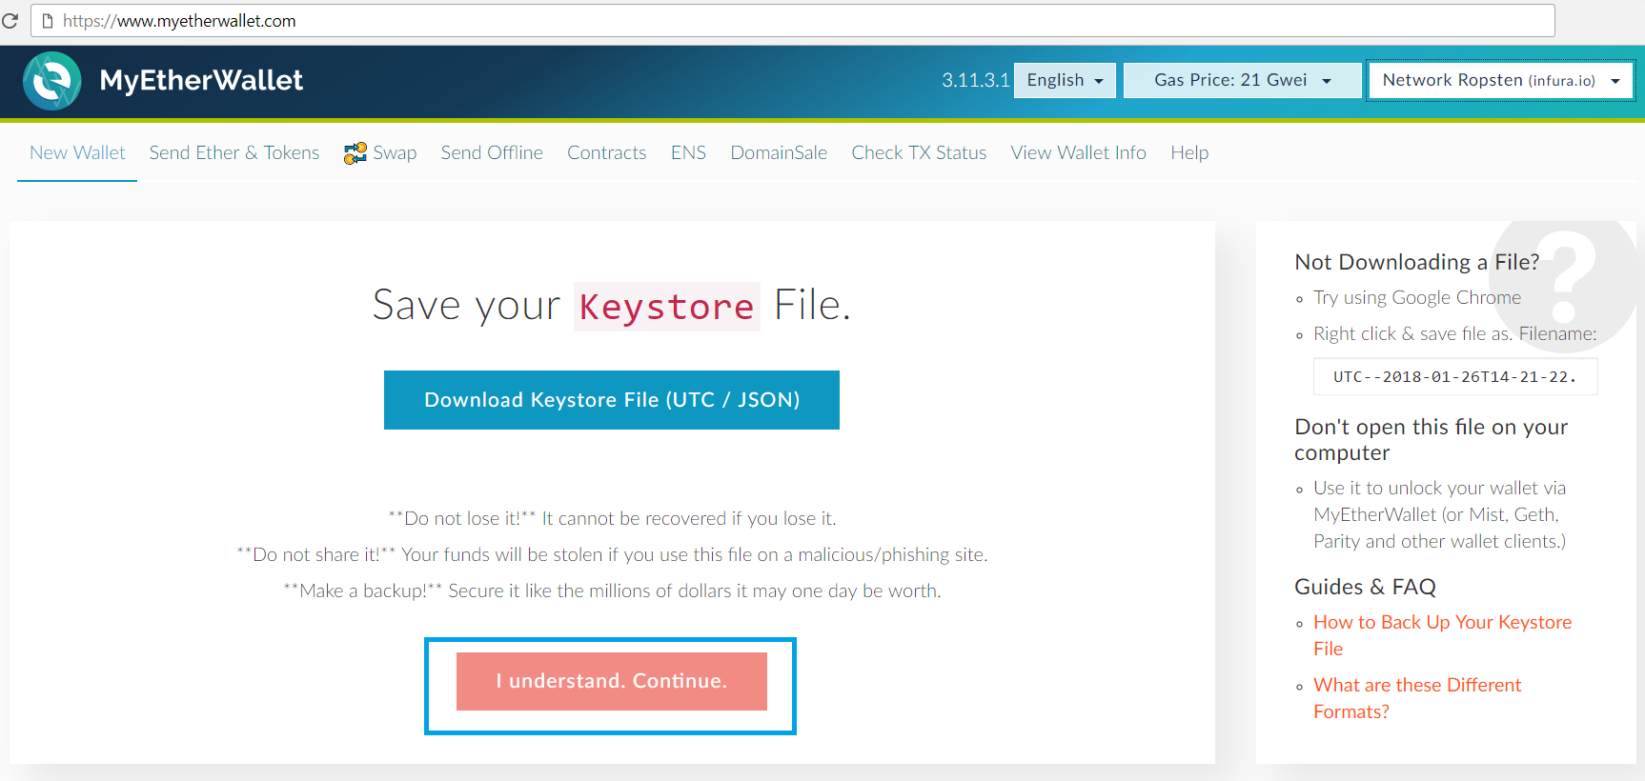

1. Optionally save your **private key** (unencrypted). Do not show it to anyone! Your private key is also stored in the encrypted JSON keystore file, so you may skip saving it unencrypted.

* ** It is not recommended to save your private key without encryption. This is a significant security risk.
* ** Keep your private key either in a **hardware wallet** (most secure) or in an **encrypted JSON keystore file** or **print it on a paper**. Avoid saving unencrypted private keys in your file system!

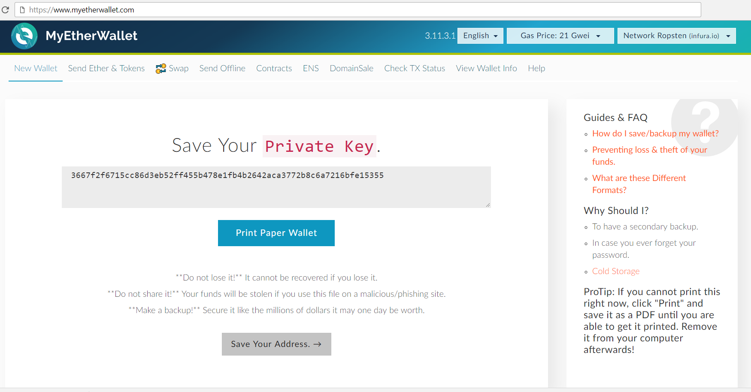

1. Now **unlock your wallet** using your JSON keystore file (decrypt it using your keystore password).

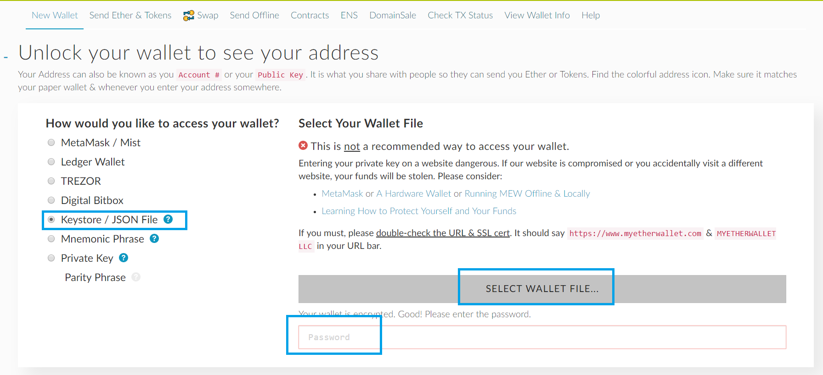

1. You can see your **Ethereum Account Address** (derived from your public key), **Token Balances**, **Account Balance** and **Private Key** there:

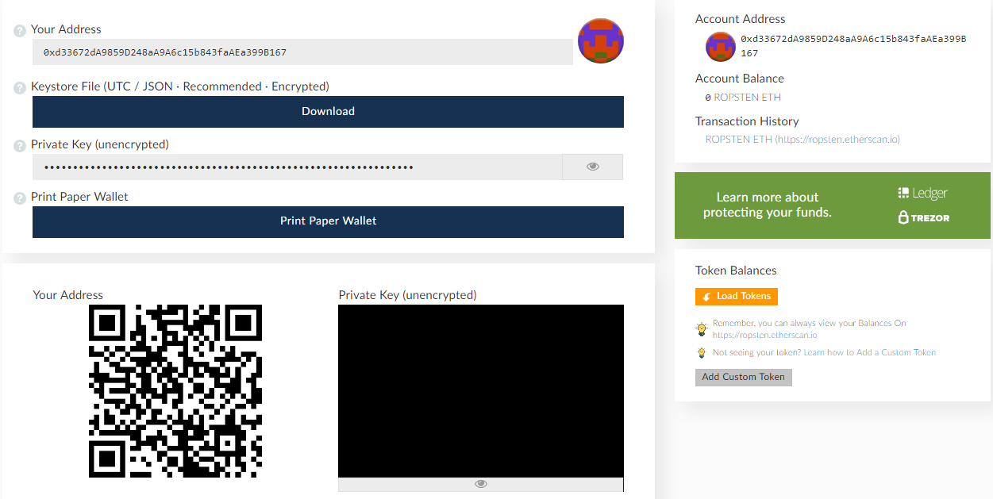

## Receive an Initial Amount of Ethers

Now you have a wallet, but it is **empty** (balance == 0 ETH). Let’s **get some ethers** to be able to play with transactions and payments. Typically, the **testnets provide coins for free**, after some kind or registration or request. We are using the Ropsten test network and it provides 1 ETH for free from the **MetaMask Faucet** (<https://faucet.metamask.io>).

**MetaMask** is a Chrome extension that provides **Web3 API in the browser** to access Ethereum networks from client-side JavaScript in the browser. It connects your browser with your Ethereum wallet. You can import Ethereum accounts (private key + address) into MetaMask and interact with the Ethereum network directly (without AJAX calls), e.g. send ethers, check account balance, publish and invoke smart contracts, etc.

1. Go to [https://metamask.io](https://metamask.io/) and download and install the MetaMask Chrome extension. **MetaMask** works in Chrome only, but is compatible with all modern operating systems like Windows, Linux and Mac.

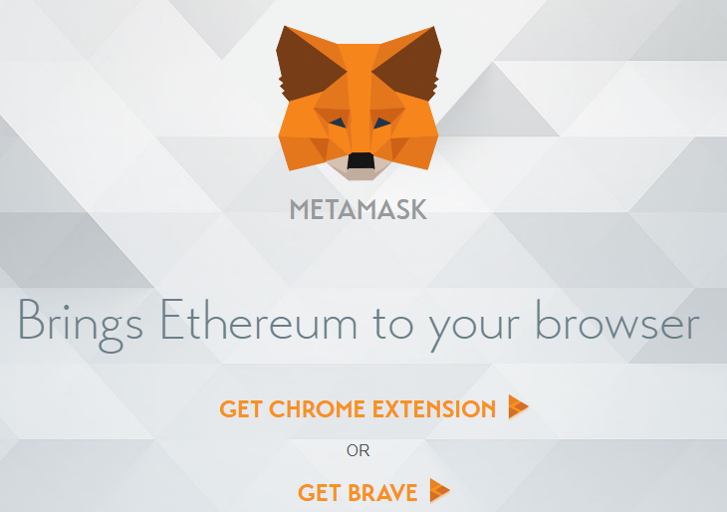

1. Run MetaMask and choose from upper left corner the **Ropsten Test Net**.

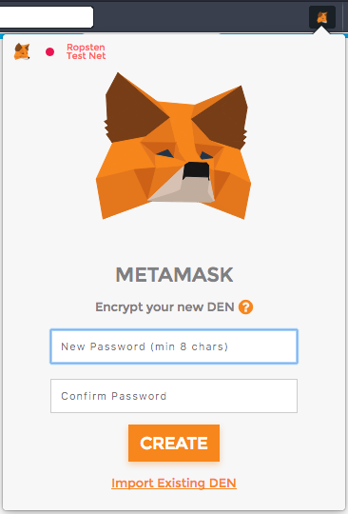

1. Now **import** the account we’ve created earlier from **myetherwallet**

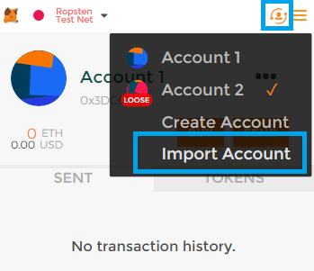

1. Type should be **JSON keystore file** then enter its password and import it.

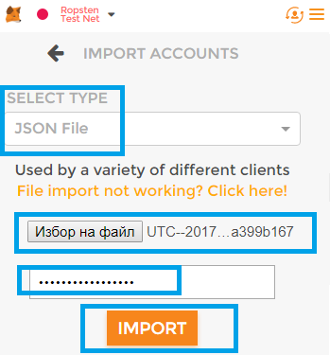

1. Then go to [https://faucet.metamask.io](https://faucet.metamask.io/) and request ether:

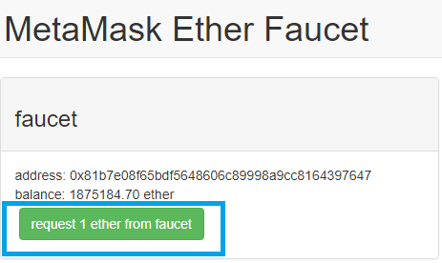

1. You can see the transaction you’ve made:

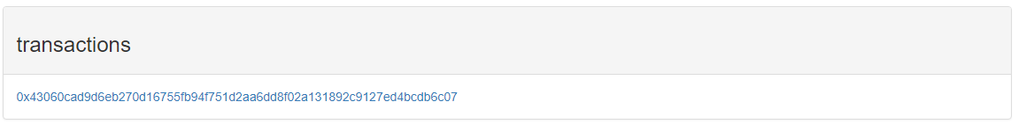

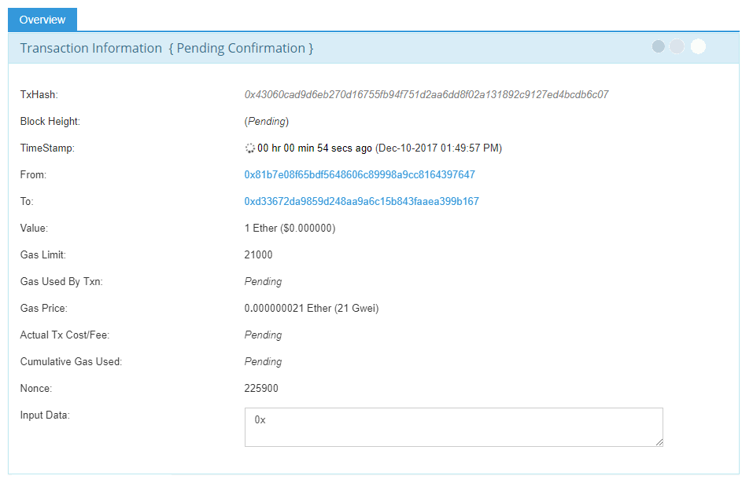

1. After the transactions are processed by the blockchain you should have ethers in your account. Go to **“View Wallet Info”** and unlock your wallet. Congrats, now you have ethers and you can operate with them!

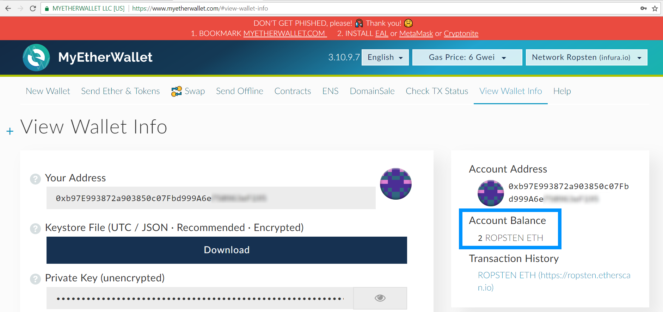

## Send Ethers to Another Address

After creating an Ethereum testnet account and receiving some ethers now you can send ethers to someone else.

1. Get someone’s address from the class and send him/her some ether, e.g. 0.5 ROPSTEN ETH.
2. Unlock your account with the **JSON file** and go to the **“Send Ethers & Tokens”** tab. Put the **address** of your mate and the **amount** you want to send. The **Gas Limit** is the default one. Generate the transaction. Then click **Send Transaction.**

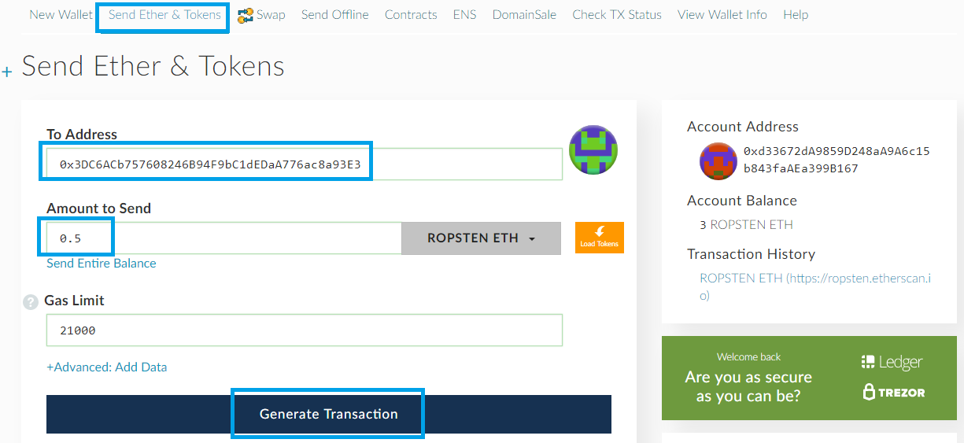

1. You will see the following window and you should click **“Yes, I am sure! Make transaction”**:

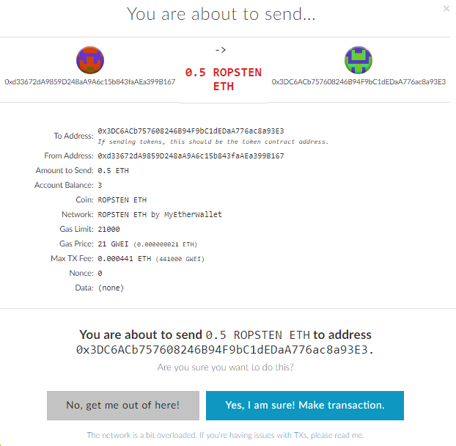

1. Now click “Verify Transaction”



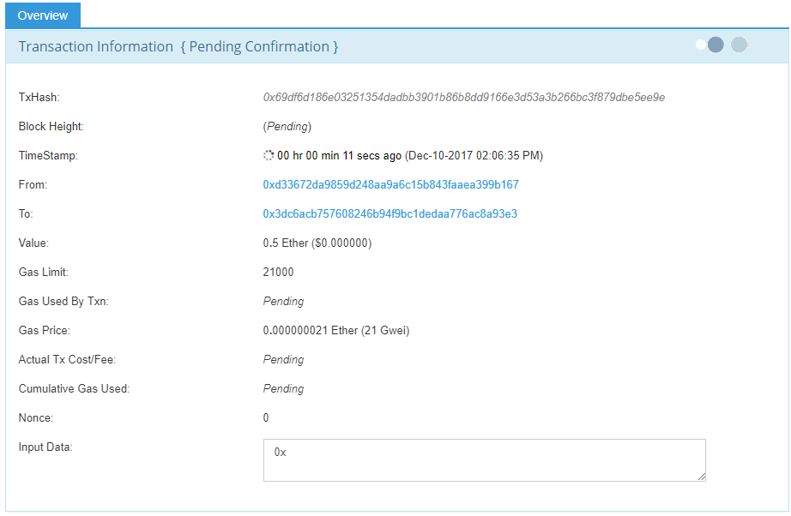

1. Now you should have smaller amount of ethers (you’ve send 0.5 but there is also a transaction fee):

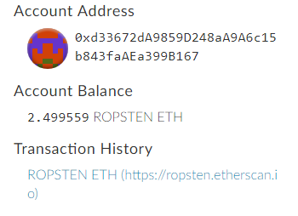

You can also see this info in MetaMask or in MyEtherWallet.

# 

# What to Submit?

Submit as exercise outcome the **URL of your Ethereum address** in the Ropsten network at EtherScan, e.g.:

* <https://ropsten.etherscan.io/address/0xb97e993872a903850c07fbd999a6e750963ef195>

You should some **ETH** in your balance, as well as some transaction history of ETH transfers.

Examples:

